**WELCOME TO FOODIE’S**

**PARADISE**

"Food for the soul, flavor for the senses."

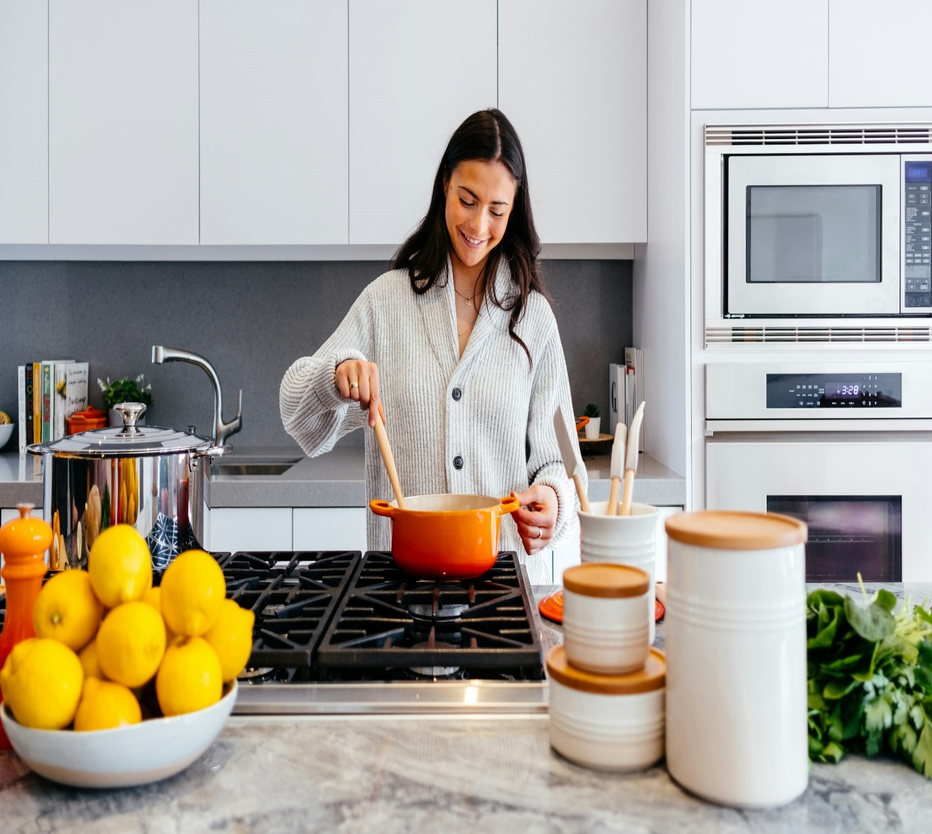

- TEAM WARRIORS

**ABOUT MY WEBSITE**

**Welcome to Foodie’s Paradise!**

Hi there, food lovers! I’m Jennifer Edward], the creator and passionate foodie behind this blog. Here, I share my culinary adventures, from easy weeknight dinners to indulgent desserts, and everything in between. Whether you’re a beginner in the kitchen or a seasoned cook, I hope to inspire and help you create delicious meals with ease.

At Foodie’s Paradise , you'll find a collection of recipes that are close to my heart. I believe food is meant to be shared, enjoyed, and savored—whether you’re cooking for yourself, your family, or friends. From flavorful, healthy dishes to mouthwatering comfort food, I’ve got something for every craving and occasion.

What makes my blog special? Besides the variety of recipes, I focus on providing clear instructions, helpful tips, and high-quality images so you can recreate these dishes in your own kitchen. If you’re looking for recipe inspiration, cooking tips, or food-related stories, you’re in the right place.

Thanks for visiting, and I’m so excited to have you join me on this tasty journey!Happy Cooking!  
Jennifer Edward   
Foodie’s Paradise

Top of Form

## **Find recipes**

[baking](https://simplefood.blog/category/baking/) [breakfast](https://simplefood.blog/category/breakfast/) [brunch](https://simplefood.blog/category/brunch/) [dessert](https://simplefood.blog/category/dessert/) [dinner](https://simplefood.blog/category/dinner/) [ideas](https://simplefood.blog/category/ideas/) [lunch](https://simplefood.blog/category/lunch/) [recipes](https://simplefood.blog/category/recipes-2/) [salad](https://simplefood.blog/category/salad/) [snacks](https://simplefood.blog/category/snacks/)

## **Facebook**

Follow [Simple Food on Facebook](https://www.facebook.com/simplefoodforyou/)  and share your photos and recipes.

## **Search for recipes**

Top of Form

Search for:

Bottom of Form

## **FOODIE’S PARADISE on Twitter**

## **Subscribe to Blog via Email**

Top of Form

Enter your email address to subscribe to this blog and receive notifications of new posts by email.

Email Address:

Subscribe

Bottom of Form

Join 541 other subscribers

## **Copyright**

All the recipes and photos on this blog are licensed under a [Creative Commons CC-BY-NC](http://creativecommons.org/licenses/by-nc/3.0/au/deed.en) licence.

### **Hosting Provider Selection**

* **Provider Chosen**: "I decided to go with [VS CODE ] for my food blog because they offer reliable service, great performance, and customer support."
* **Reason for Choosing**: "After researching various options, I found [VS CODE ] to be the most suitable for my blog due to their easy integration with WordPress, fast page load times, and affordable plans."

### **Domain Registration**

* **Domain Name**: "I picked my domain name, **FOODIE’S PARADISE.com**, because it’s catchy, easy to remember, and clearly reflects the content of my blog."
* **Where You Registered the Domain**: "I registered my domain with VS CODE , as they offered a simple and user-friendly platform to manage both my hosting and domain in one place."
* **Free Domain Offer**: "Since I chose VS CODE, they offered a free domain registration for the first year, which saved me money on initial setup."

### **Website Setup and Configuration**

* **CMS Installation**: "I used WordPress to create my blog, as it’s user-friendly, customizable, and has plenty of plugins for food bloggers. My hosting provider made installing WordPress very easy with just one-click installation."
* **Customization**: "Once WordPress was installed, I customized my theme, installed necessary plugins (like recipe cards, SEO tools, and social sharing buttons), and set up the structure of my website to match my brand."

### **Performance and security**

* **Performance Features**: "To ensure my food blog runs smoothly, I enabled [caching/CDN/other performance-enhancing features]. This helps with faster load times, especially since food blogs often feature high-quality images."
* **SSL and Security**: "I made sure to enable SSL (Secure Sockets Layer) to encrypt my site, ensuring that visitors feel safe when browsing and subscribing to my newsletter. [Hosting Provider] offers a free SSL certificate, which was a great bonus."

### **Ongoing Maintenance and Support**

* **Automatic Backups**: "I set up automatic backups using [Backup Plugin/Hosting Feature], so if anything goes wrong, I can quickly restore my site."
* **Support**: "I also have access to 24/7 support from [Hosting Provider], which is reassuring if I ever run into any technical issues."

*For my food blog, I chose Bluehost as my hosting provider because they offer reliable performance, excellent customer support, and an easy integration with WordPress. I started with their shared hosting plan, which is perfect for beginners like me. Bluehost also provides a free domain registration for the first year, which made the initial setup even easier. I registered my domain name through them,* ***foodiesparadise.com****, because it was short, catchy, and reflected the content of my blog.*

*I installed WordPress using Bluehost's one-click install feature, which made setting up the blog incredibly easy. After installation, I customized my theme and added plugins like recipe cards, SEO tools, and social sharing buttons to enhance the user experience. To improve website performance, I enabled caching through Bluehost’s built-in features.*

*Security was a priority, so I enabled SSL for free, ensuring that my site is secure and that visitors feel comfortable browsing. I also set up automatic backups through Bluehost, so I never have to worry about losing any content.*

*The cost of my hosting plan is $3.95/month, which includes both hosting and the free domain for the first year. Given all the features I get, I think this is a great value for someone just starting their food blog.*

*Overall, Bluehost has been great for getting my blog up and running, and I feel*

*Website launch*

**Set up the environment**: Install **Visual Studio Code** (VS Code) and create a project folder.

• **Create essential files**: Inside the project folder, create an index.html file for the structure, style.css for the design, and script.js for interactivity (optional).

• **Write the HTML**: Add the structure of the webpage with elements like headers, paragraphs, and navigation.

• **Style with CSS**: Customize the look of the webpage (fonts, colors, layout) using the style.css file.

• **Add JavaScript (optional)**: Enhance interactivity with JavaScript (e.g., pop-ups, form validation).

• **Preview**: Open the HTML file in a browser to see your website.

• **Publish (optional)**: Host your website on platforms like GitHub Pages, Netlify, or Vercel for free, or use paid hosting.

**Conclusion of Website Launch:**

Launching a website is a significant milestone in the development process. It marks the completion of planning, design, and coding efforts, bringing your online presence to life. After thoroughly testing the website for functionality, usability, and performance, publishing it to a hosting platform ensures it's accessible to users worldwide. The launch not only provides a space for visitors to interact with your content but also offers an opportunity for continuous improvement based on feedback and analytics. A successful website launch signifies the start of ongoing maintenance, optimization, and potential growth as you expand and refine your online presence.

Thank you for your time, and I look forward to seeing how this project

progresses!

